Figure 1

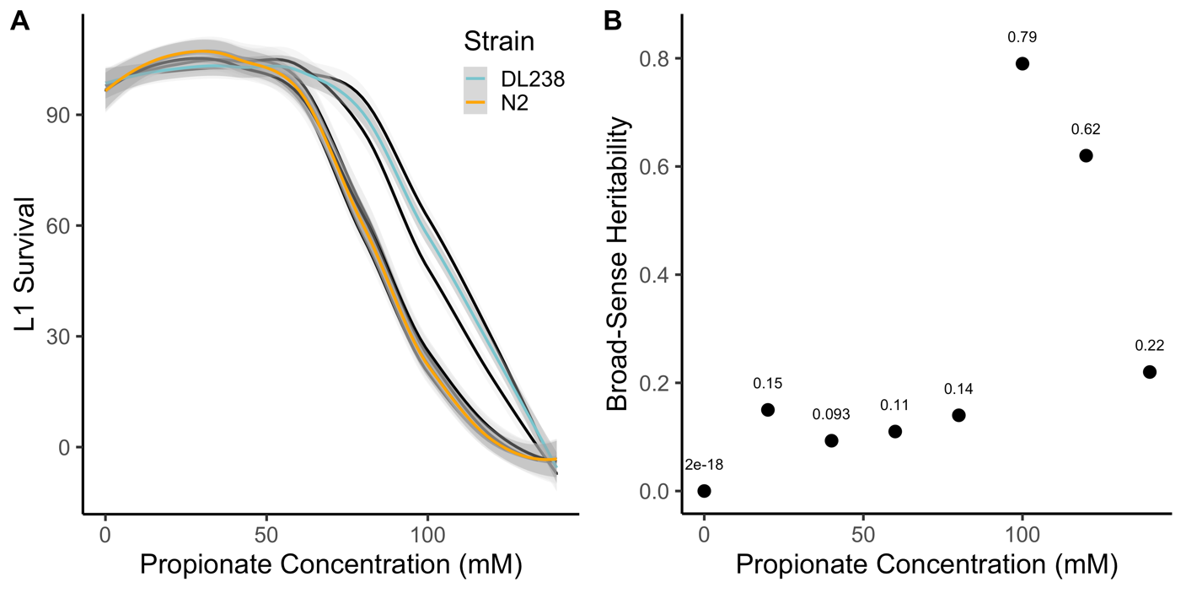

**Propionate dose response**

(**A**) The percentages of L1 survival for 12 genetically distinct *C. elegans* strains are shown on the y-axis for increasing concentrations of propionate (0, 20, 40, 60, 80, 100, 120, 140 mM) on the x-axis. The Loess-smoothed fits of three technical and three biological replicates are represented by solid lines and the standard error of the fit is shown in gray. For reference, the N2 (orange) and DL238 (light blue) strains are colored. (**B**) Broad-sense heritability estimates are shown on the y axis for each concentration of propionate on the x axis.

Supplemental Figure 1

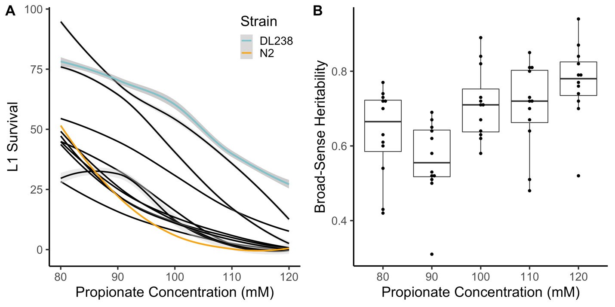

**Fine-scale propionate dose response**

(**A**) The percentages of L1 survival for 12 genetically distinct *C. elegans* strains are shown on the y-axis for increasing concentrations of propionate (80, 90, 100, 110, 120 mM) on the x-axis. The Loess-smoothed fits of three technical and three biological replicates are represented by solid lines and the standard error of the fit is shown in gray. For reference, the N2 (orange) and DL238 (light blue) strains are colored. (**B**) Tukey boxplots of broad-sense heritability (*H2*) estimates are shown on the y axis for each concentration of propionate on the x axis. Each point corresponds to an *H2* estimate after subsampling three replicate measures.

Supplemental Figure 2

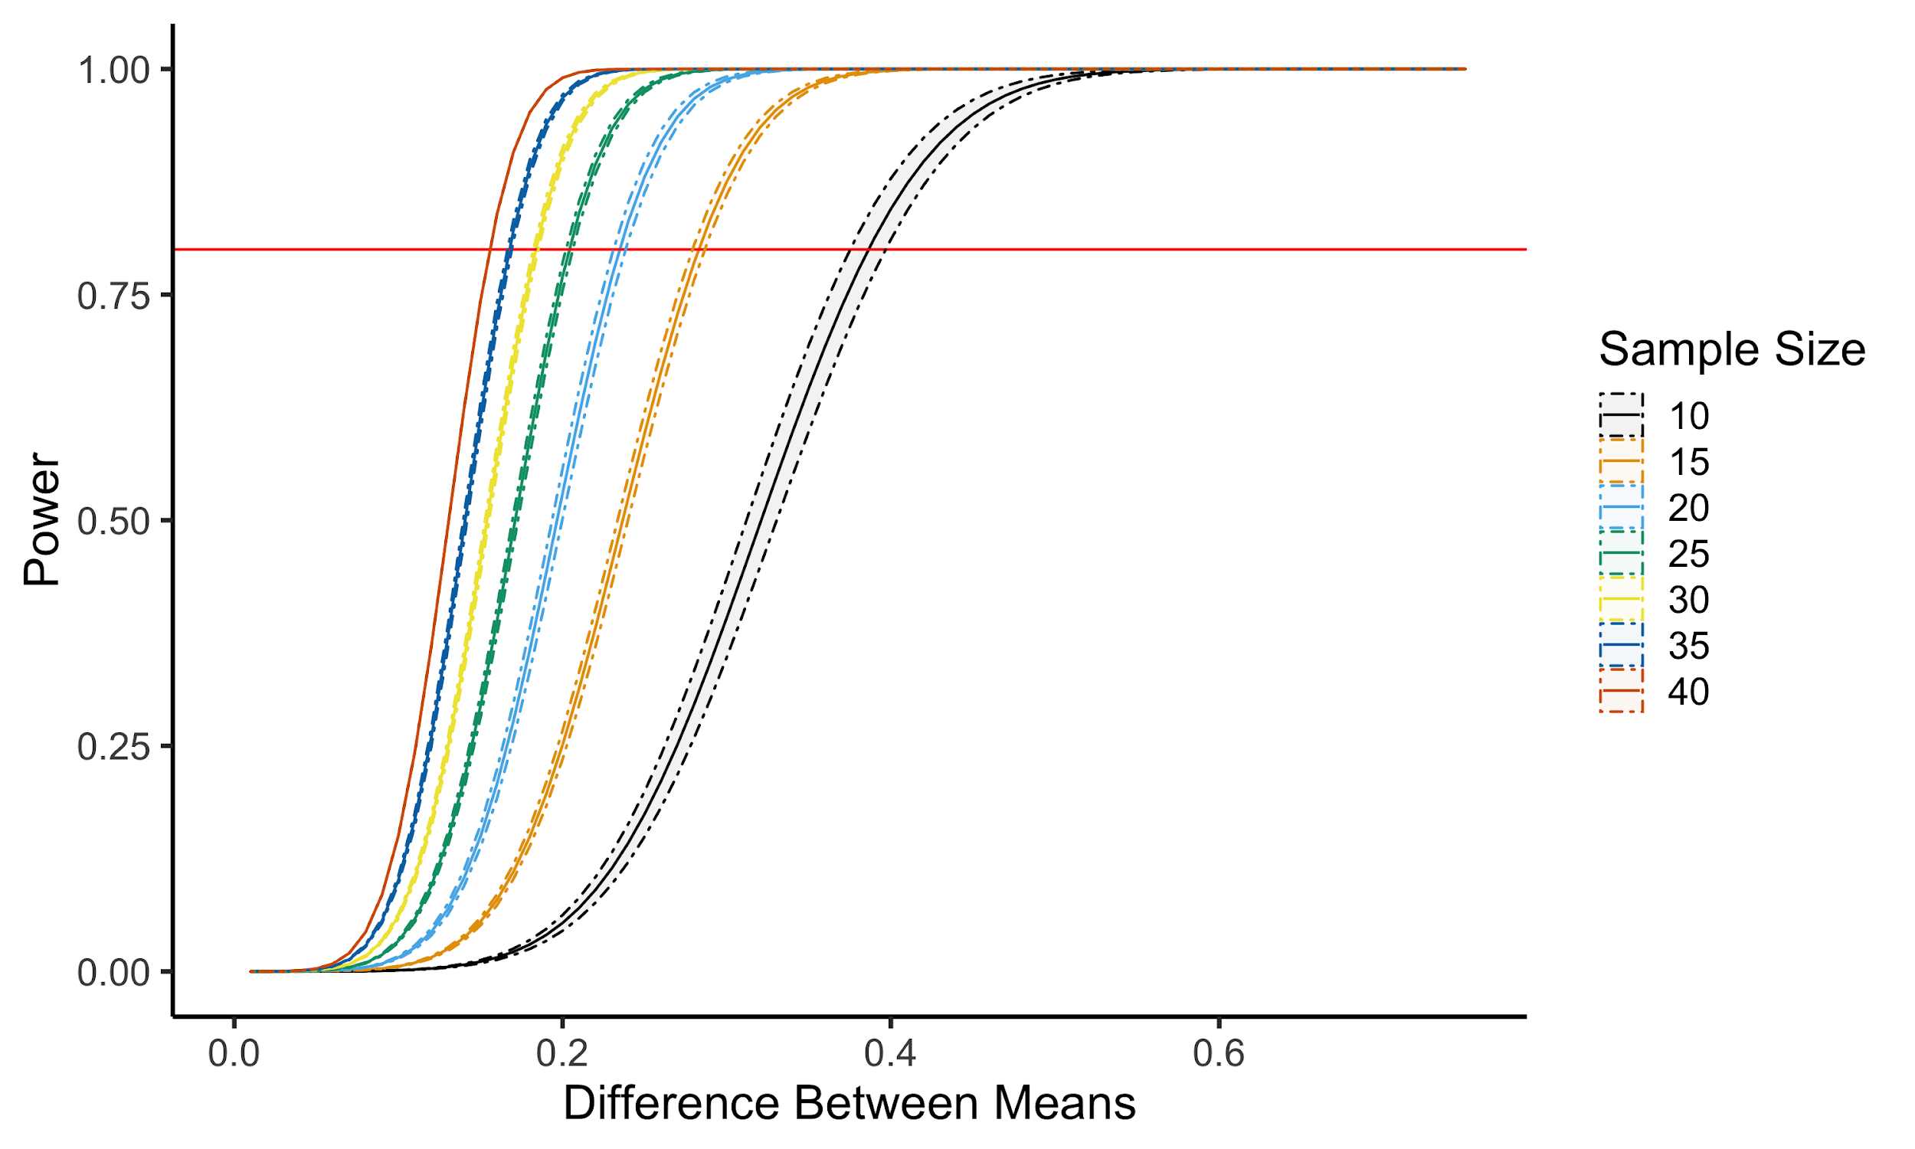

**Power calculation**

(**A**) Power analysis of L1 survival after propionate exposure is shown. We calculated power for a range of mean differences from 0 to 1, using the average standard deviation of 100 subsamples from a large-scale experiment that measured DL238 propionate survival. The solid line represent the mean of 10 replicate power calculations and the dashed lines represent the standard deviation of the replicates. Colors represent the sample size.

­­­­

Figure 2

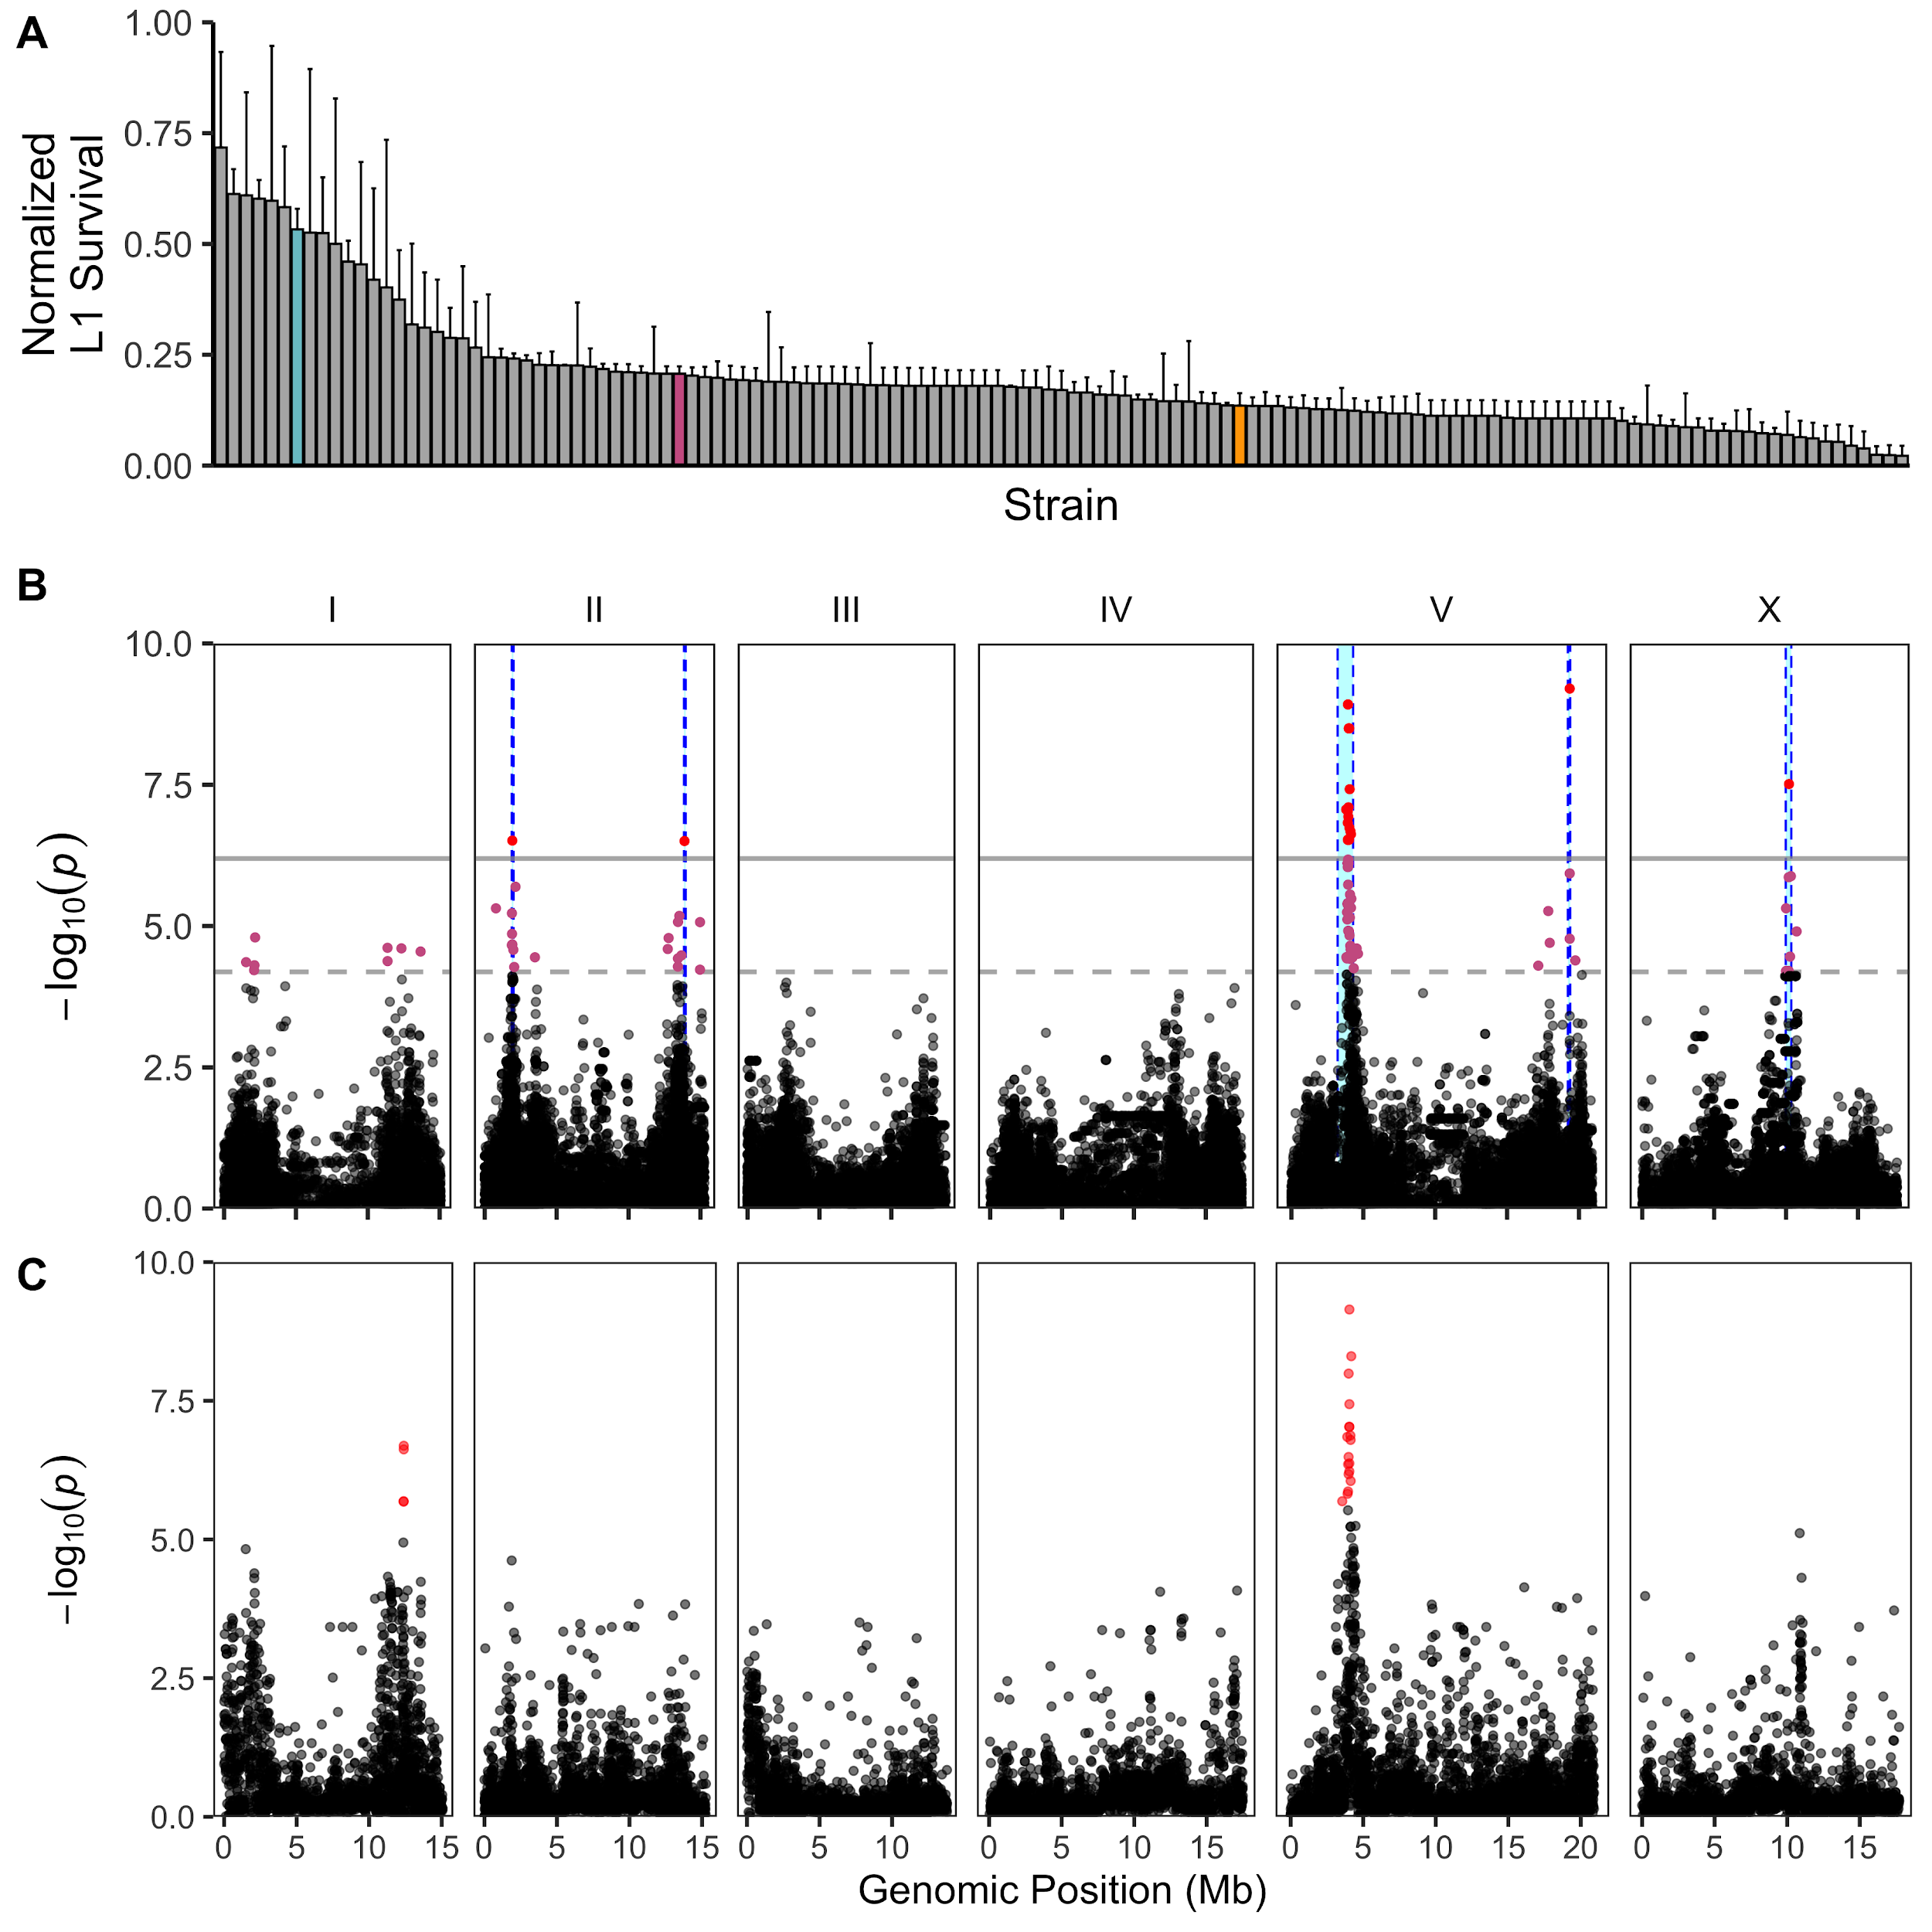

**Multiple QTL are associated with variable propionate sensitivity among *C. elegans* strains**

(**A**) Normalized L1 survival in the presence of 100 mM propionate for individual wild *C. elegans* strains is shown. L1 survival percentages were normalized by dividing each strain measurement by the maximum L1 survival percentage of all strains. Error bars show the standard deviation of replicate strain measurements. Colored bars correspond to N2: orange, DL238, blue, and BRC20067 pink. (**B**) A Manhattan plot for the L1 survival percentage after propionate exposure is shown. Each point represents an SNV that is present in at least 5% of the assayed wild population. The genomic position in Mb, separated by chromosome, is plotted on the x-axis and the *-log10(p)* for each SNV is plotted on the y-axis. SNVs are colored red if they pass the genome-wide Bonferroni-corrected significance (BF) threshold, which is denoted by the gray horizontal line. SNVs are colored pink if they pass the genome-wide Eigen-decomposition significance (ED) threshold, which is denoted by the dotted gray horizontal line. The genomic regions of interest surrounding the QTL that pass the BF are represented by cyan rectangles. (**C**) The results from SKAT burden mapping for L1 survival after propionate exposure are shown. Each point represents a gene and are colored red if they pass the genome-wide Bonferroni-corrected significance (BF) threshold. The genomic position in Mb, separated by chromosome, is plotted on the x-axis and the *-log10(p)* for each gene is plotted on the y-axis.

Supplemental Figure 3

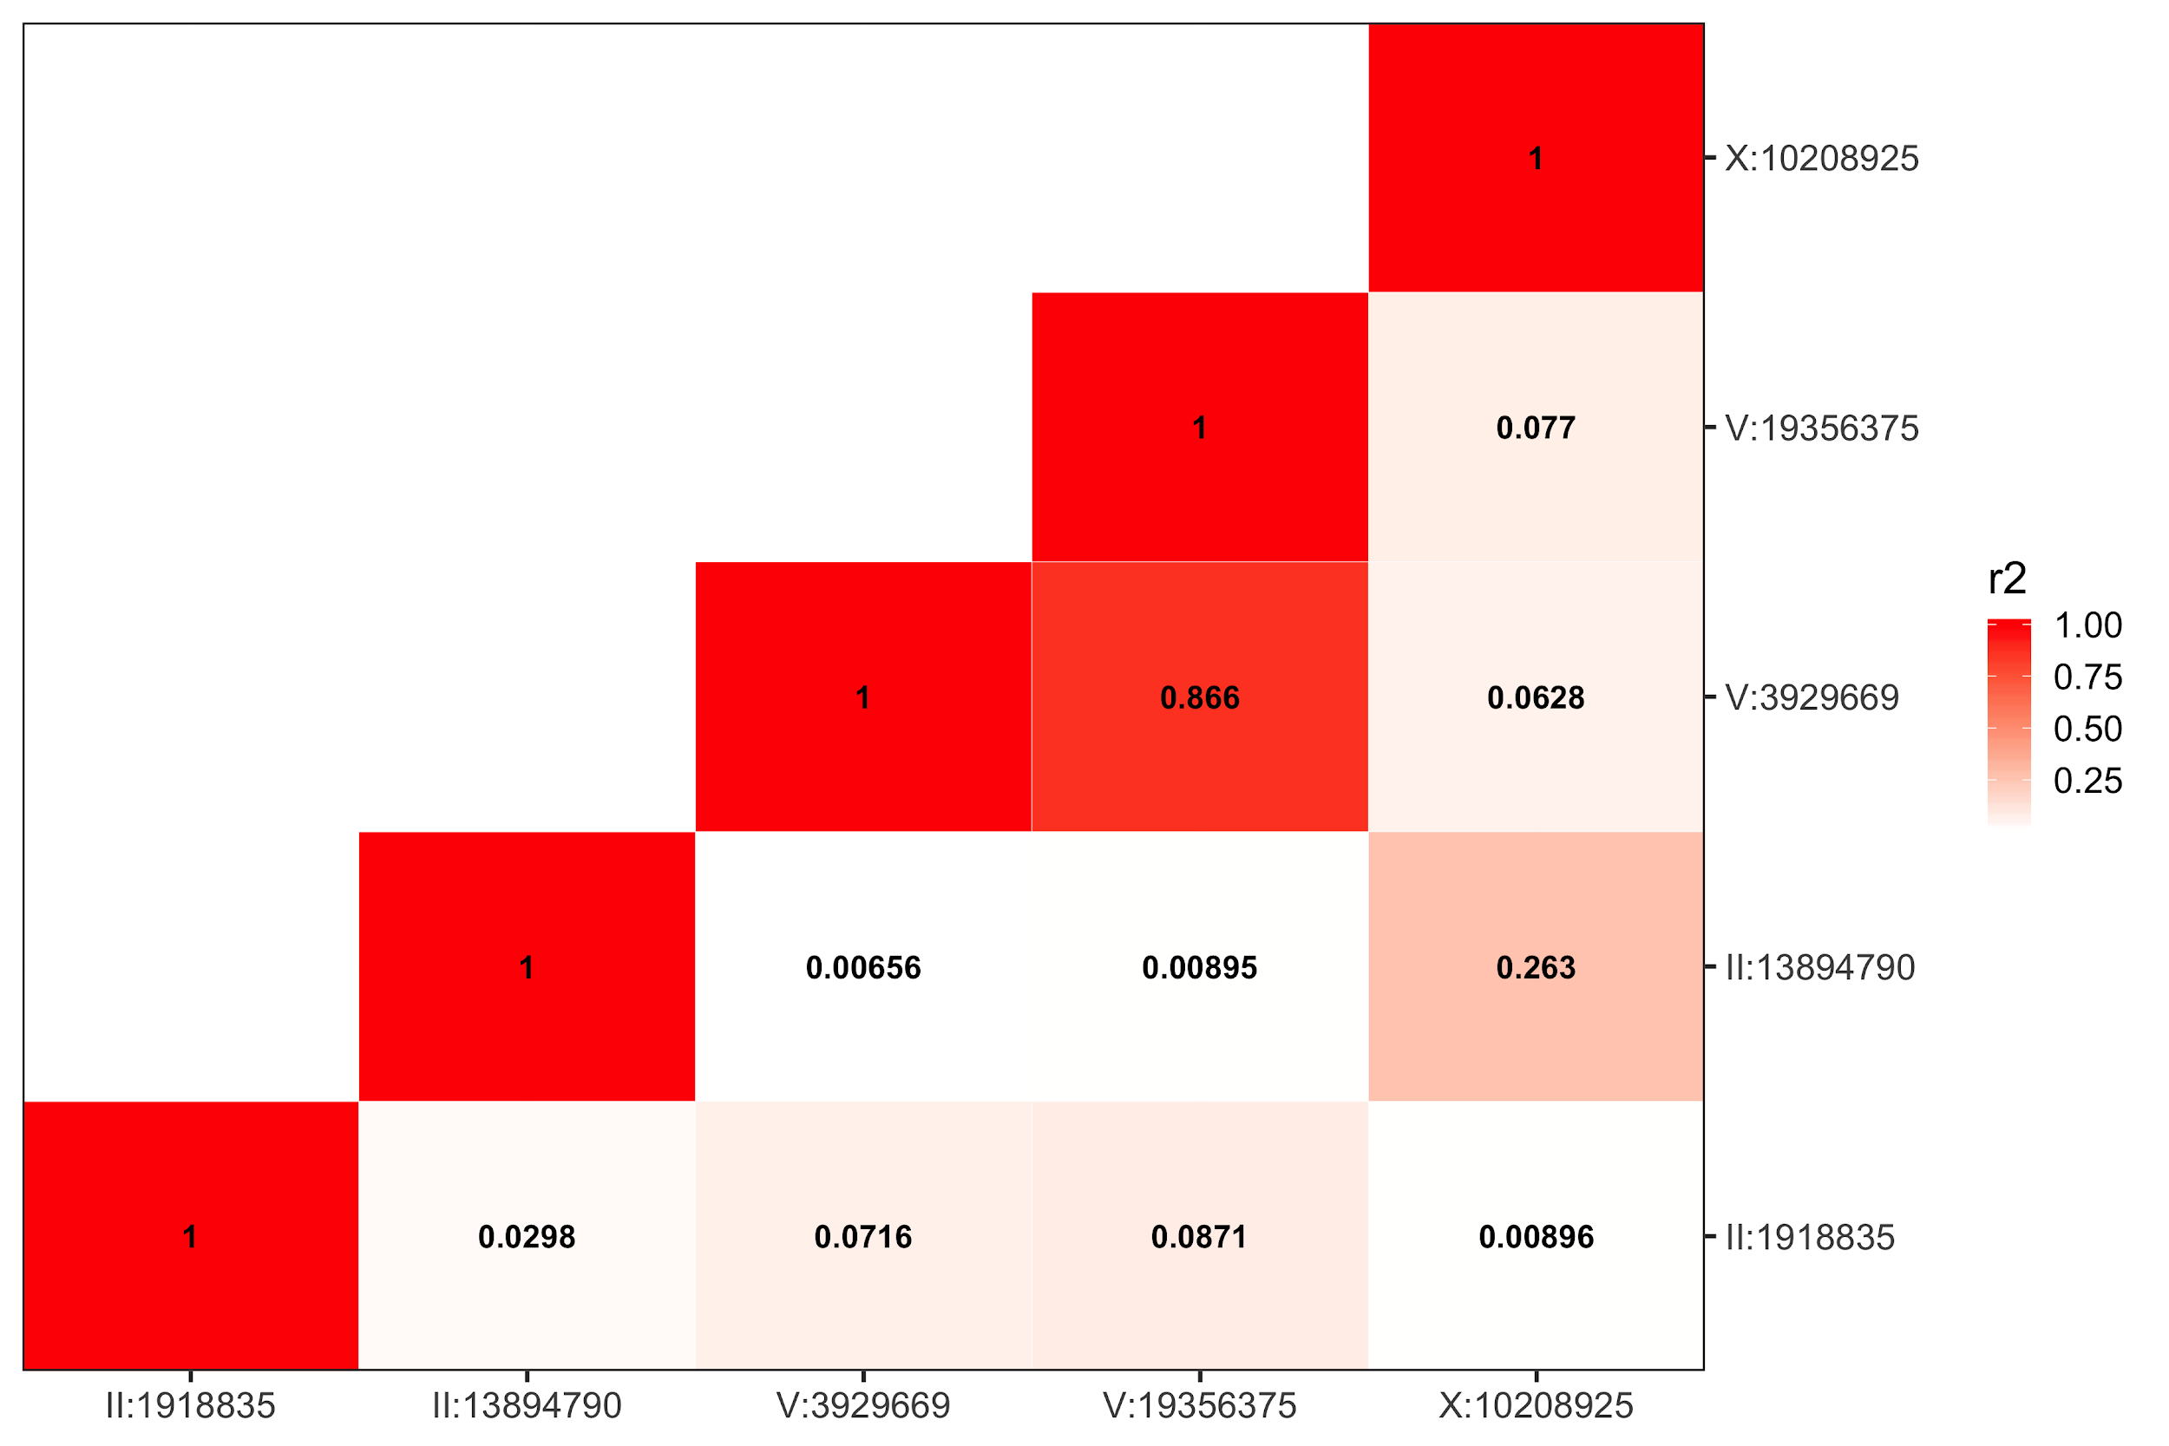

**Linkage disequilibrium of QTL peaks identified by genome-wide association mapping**

Linkage disequilibrium (*r2*) of peak QTL markers identified by genome-wide association mapping. The peak markers for each QTL identified by GWA mapping are shown on the y and x-axes. The linkage disequilibrium between QTL peak markers are represented by a heatmap, where marker pairs in higher LD are more red in color.

Figure 3

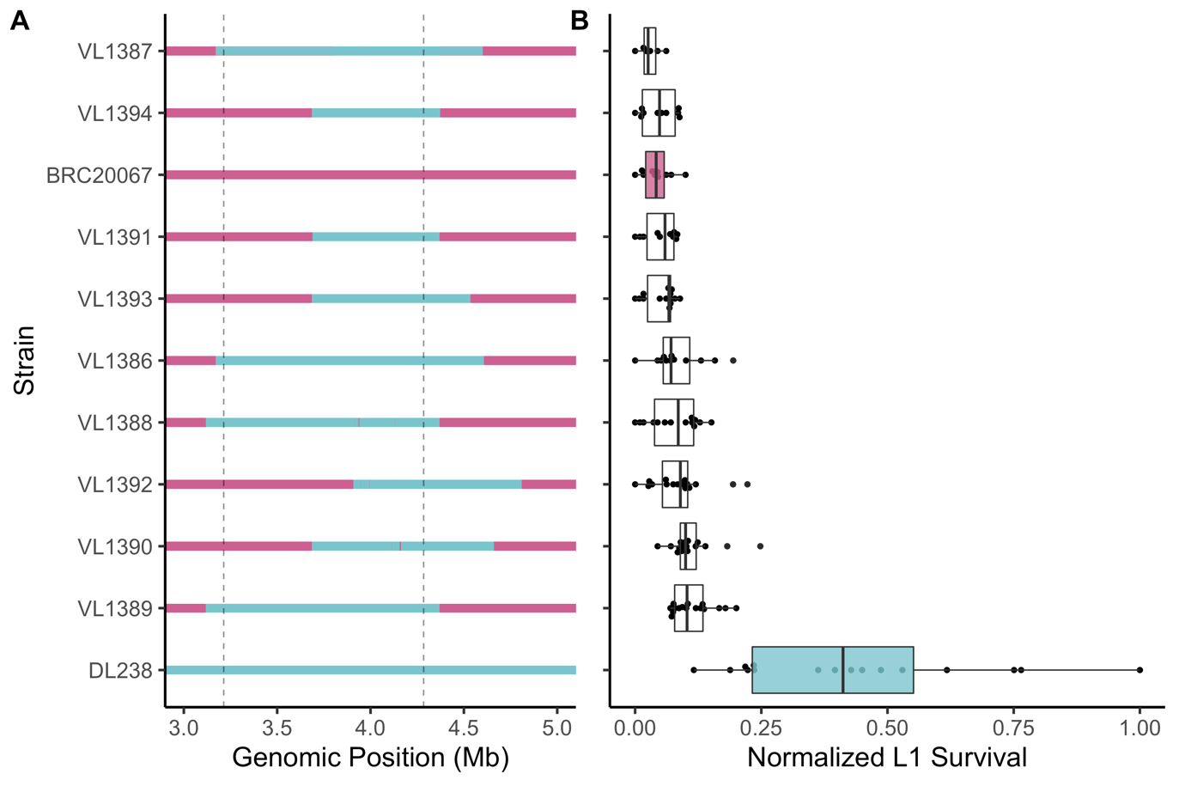

**Chromosome V near-isogenic lines do not recapitulate propionate resistance**

(**A**) Chromosome V genotypes of near-isogenic lines (NILs) generated between BRC20067 and DL238 are shown. Light blue corresponds to the DL238 genotype, and pink corresponds to the BRC20067 genotype. (**B**) Tukey box plots of the L1 survival percentages of each NIL and parental strains are shown on the x axis. Each point represents a replicate L1 survival measurement. The red dotted line represents the mean L1 survival of the parental BRC20067 strain.

Supplemental Figure 4

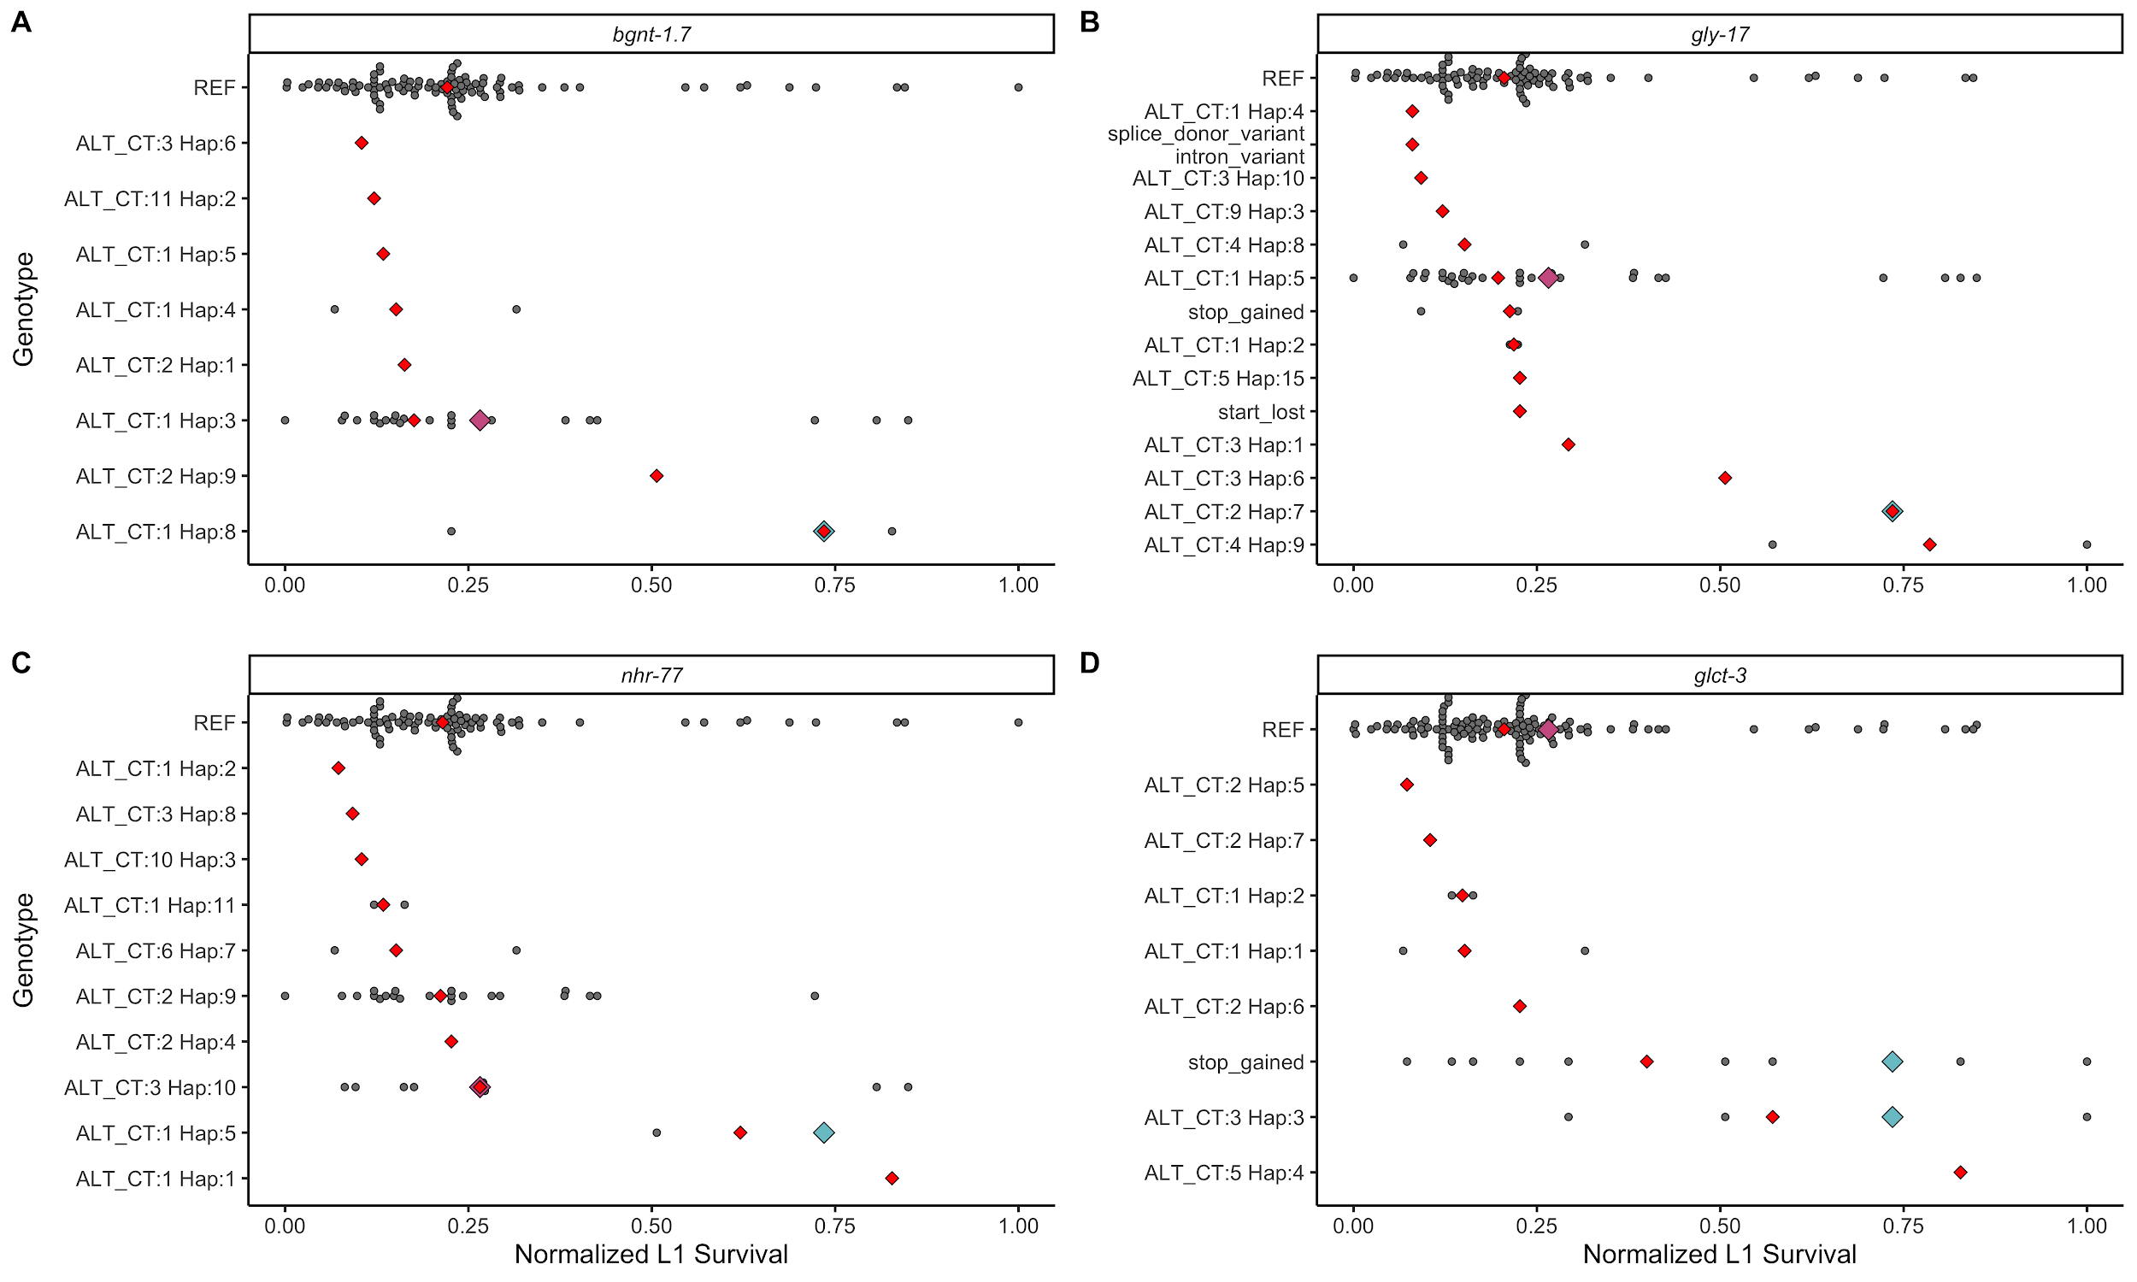

**Variation in chromosome I genes associated with propionate sensitivity**

The normalized L1 survival in the presence of propionate for each phenotyped *C. elegans* strain is shown on the x-axis. The y-axis represents unique haplotypes constructed from variants with moderate-to-severe predicted effects on gene function for each gene found to be significantly associated with propionate sensitivity. The haplotype notation ALT_CT:x Hap:y refers to the alternate genotype count (ALT_CT) and the unique haplotype (Hap) for each gene: (**A**) *bgnt-1.7*, (**B**) *gly-17*, (**C**) *nhr-77*, and (**D**) *glct-3*. If a variant with a high predicted effect on gene function was identified, we plotted it separately. The red diamonds represent the median phenotype value for each unique haplotype. The blue and pink diamonds represent the DL238 and BRC20067 strains, respectively.

Figure 4

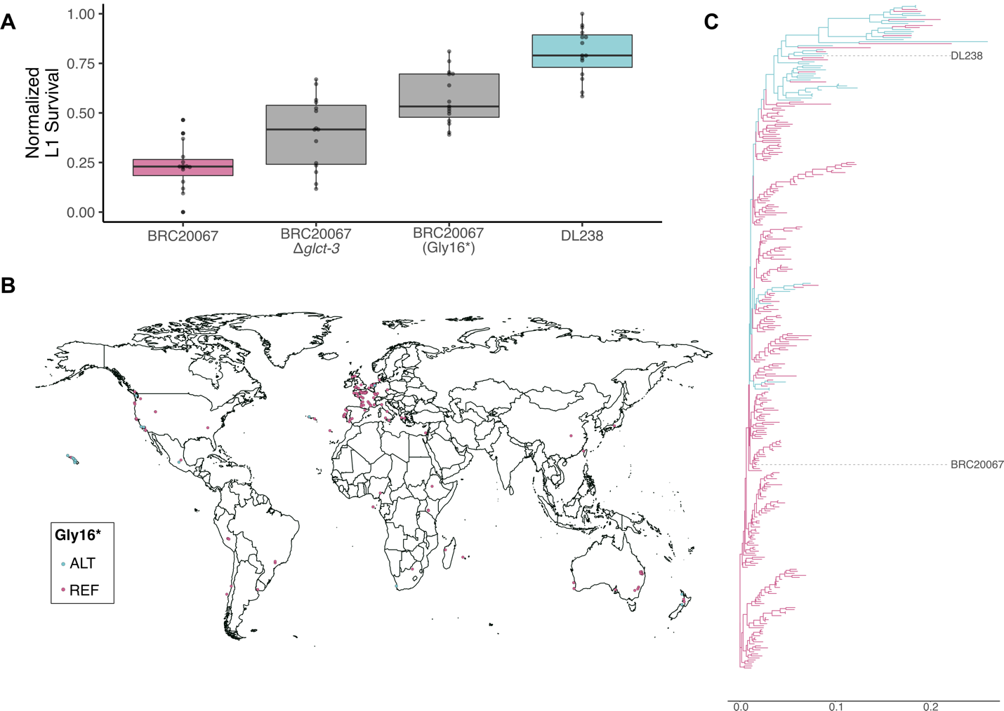

**Variation in *glct-3* underlies differential propionate sensitivity in *C. elegans***

(**A**) Tukey box plots of the L1 survival phenotypes of each CRISPR-edited and parental strains is shown on the y-axis. Each point represents a replicate L1 survival measurement. (**B**) The global distribution of the GLCT-3(Gly16*) allele is shown. Each point represents the sampling location of a *C. elegans* strain. Blue points represent strains with the stop-gained allele, and pink points represent strains with the reference allele. (**C**) The genome-wide phylogeny of 330 C. elegans strains showing that the GLCT-3(Gly16*) allele tends to be present in divergent *C. elegans* strains. The colors of individual branches correspond to strains with the GLCT-3(Gly16*) allele and have the same color code as in panel B.

Supplemental Figure XX

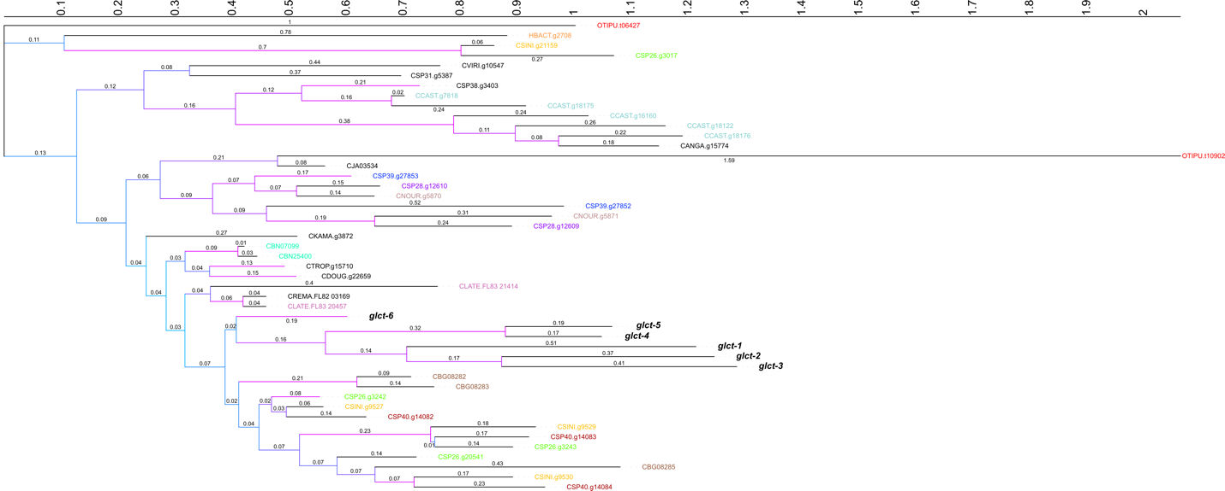

**Phylogenetic relationship of *glct-3* homologous cDNA sequences**

The maximum likelihood phylogenetic relationship of *glct-3* homologs is shown. Branch lengths are shown above each branch. Branch colors correspond to the bootstrap support for the split, with pink indicating higher support. If a species contains more than homolog, all homologs for that species are colored the same color. Species with only one homolog are colored black. The *C. elegans glct* genes are colored in black and bolded.

Figure 5

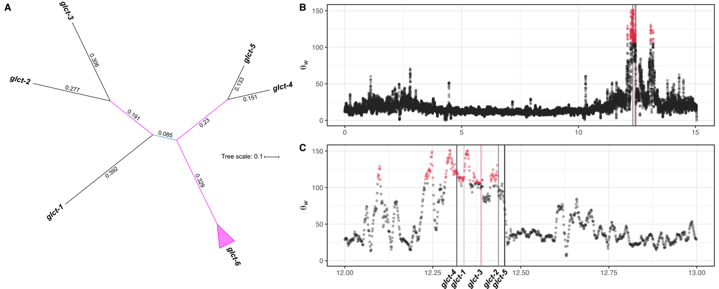

**Variation in *glct-3* underlies differential propionate sensitivity in *C. elegans***

(**A**) The maximum likelihood phylogenetic relationship of *C. elegans* *glct-3* paralogs is shown. Branch lengths are shown above each branch. Branch colors correspond to the bootstrap support for the split, with pink indicating higher support. (**B**) Watterson’s theta (Θw) estimates for 10 kb bins along chromosome I are shown. Bins with the the top 1% Watterson’s theta estimates are highlighted in red. The position of *glct-3* is highlighted with a pink vertical line. (**C**) A zoomed in version of panel B is shown. The genomic positions of the five *glct* paralogs located on this chromosomal region are highlighted with vertical lines.

Supplemental Figure XX

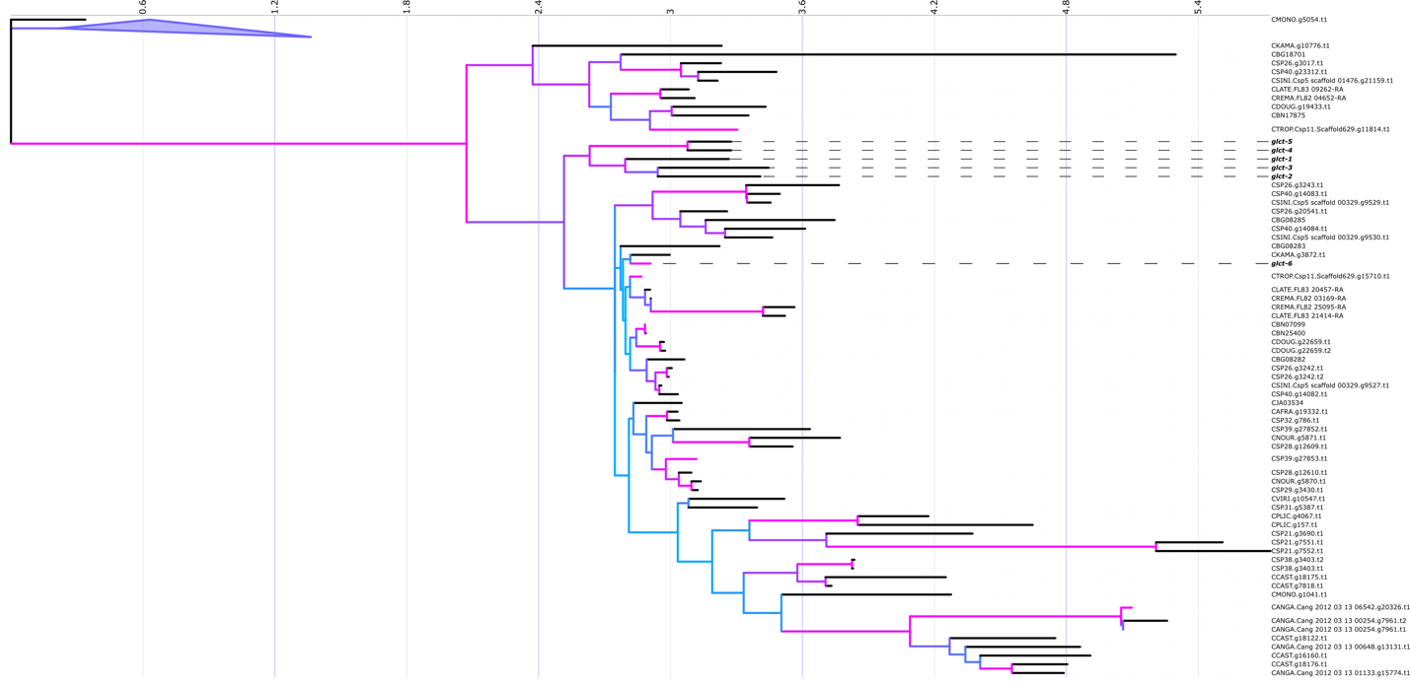

**Phylogenetic relationship of GLCT-3 homologous protein sequences**

The maximum likelihood phylogenetic relationship of *glct-3* homologs is shown. Branch colors correspond to the bootstrap support for the split, with pink indicating higher support. The *C. elegans* GLCT protein sequences are bolded.

END FIGURES

Figure 4

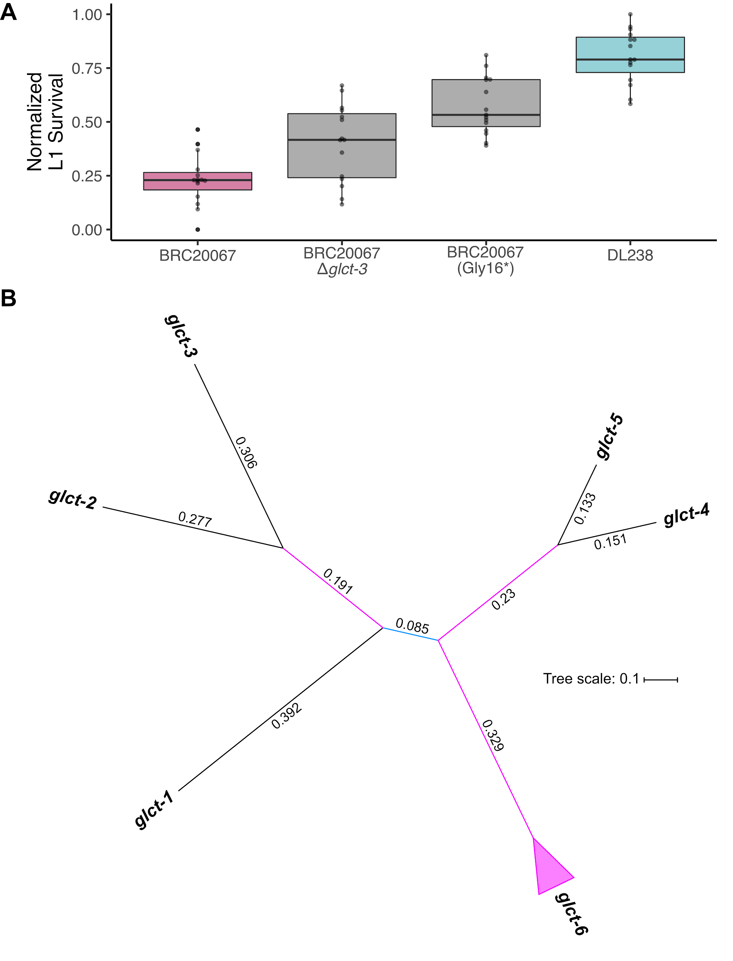

**Variation in *glct-3* underlies differential propionate sensitivity in *C. elegans***

(**A**) Tukey box plots of the L1 survival phenotypes of each CRISPR-edited and parental strains is shown on the y axis. Each dot represents a replicate L1 survival measurement. (**B**) An unrooted maximum-likelihood phylogeny of the six glucuronosyl transferase-like gene coding sequences present in the *C. elegans* genome. Branch colors correspond to the bootstrap support for the split, with pink indicating higher support.

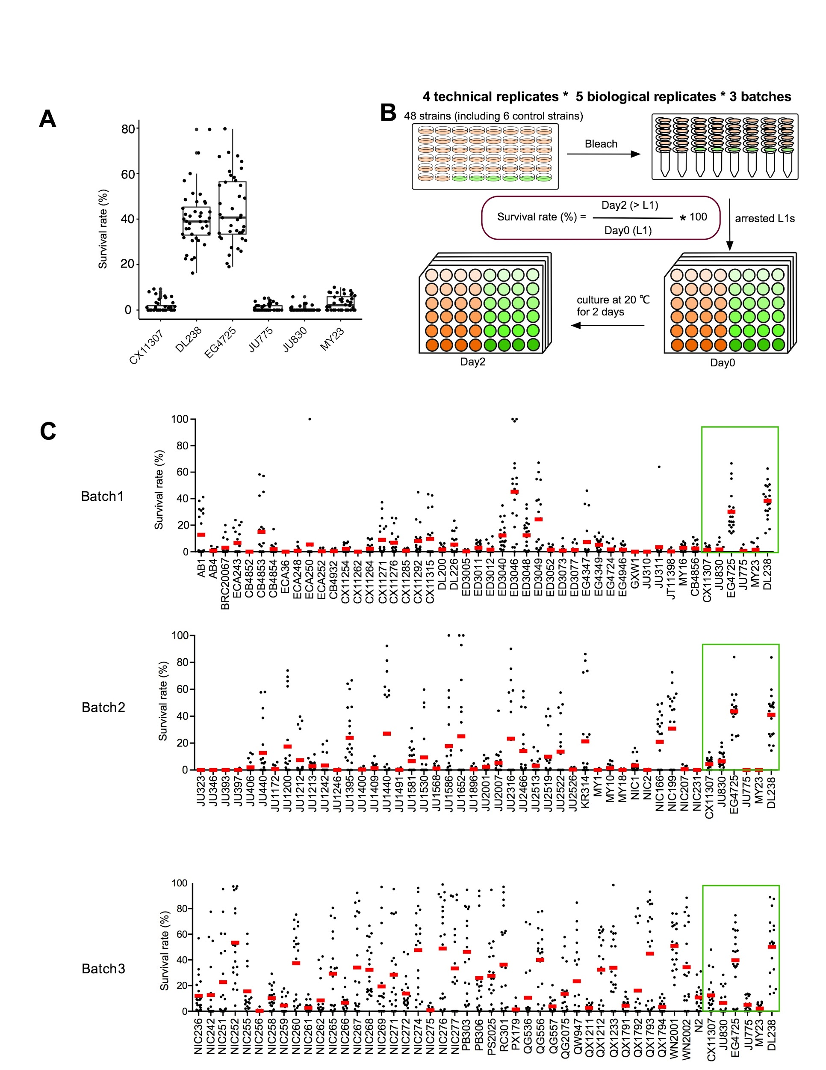

**132 wild isolated *C. elegans* strain show a broad range of propionate sensitivity**

(**A**) 6 strains were selected as control for batch effect. 2 out of 6 strain show propionate resistance. (**B**) Diagram of 48 well format propionate sensitivity assay. 132 strains were assayed in 3 batches, and each batch contains 48 strains (including six control strains), each strain has 5 biological and 4 technical replicates yield 20 data points. (**C**) Plots of all the data points, and red bar indicate mean survival rate of 20 data points. (**D**) Normalized wild isolates propionate sensitivity result. (**E**) GWAS QTL linkage disequilibrium**.**

Figure 4

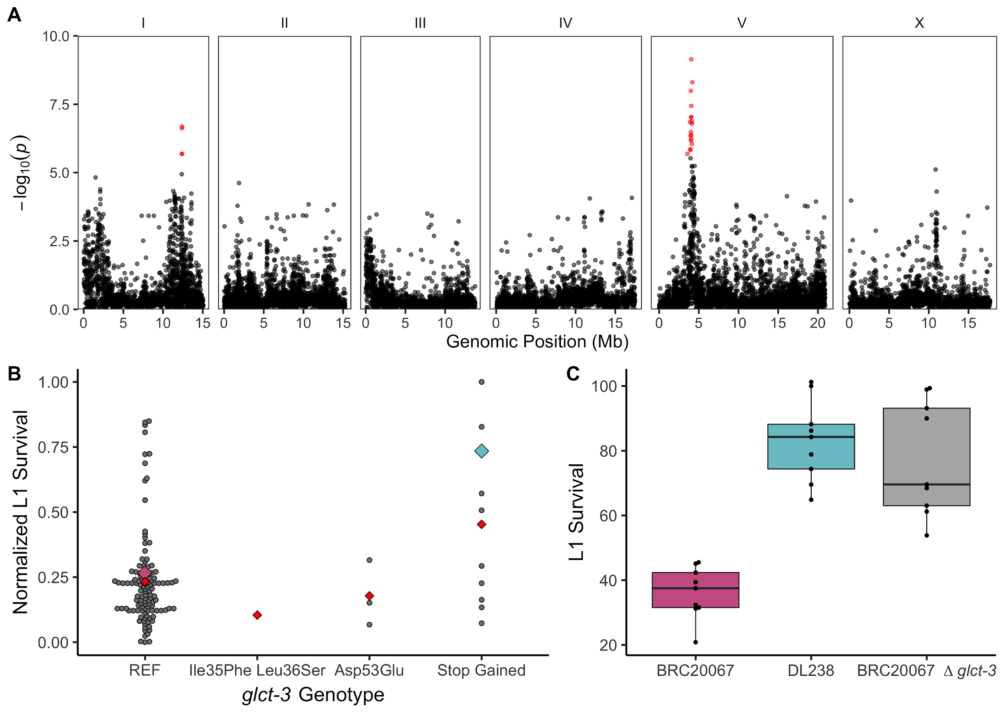

**Loss of *glct-3* confers propionate resistance**

(**A**) The results from SKAT burden mapping for L1 survival after propionate exposure are shown. Each dot represents a gene and are colored red if they pass the genome-wide Bonferroni-corrected significance (BF) threshold. The genomic position in Mb, separated by chromosome, is plotted on the x-axis and the *-log10(p)* for each gene is plotted on the y-axis. (**B**) The L1 survival of C. elegans strains Single-nucleotide variants present in the glct-3 among the phenotyped population are shown on the x axis. T

Point deletion mutant of *glct-3* in BRC20067 background confer propionate resistance, to the identical degree as DL238. (**B**) genotype and phenotype correlation analysis of *glct-3* variations.

**MISC**

**Genome assemble - look at these contigs that overlap with glct-3 from assembly. have they been polished?**

(~/Dropbox/AndersenLab/LabFolders/Stefan/Collaborations/propionic_acid/pacbio/proper_alignment )

12384545 12385900 7358 5992 1356 1367 83.54 0.01 5.17 I scaffold_586

12388549 12401479 1 13103 12931 13103 96.25 0.09 63.59 I scaffold_770

12390360 12390979 8752 8130 620 623 84.87 0.00 3.02 I scaffold_770

12399321 12400607 4522 3244 1287 1279 84.21 0.01 4.83 I scaffold_586

12402719 12410160 13100 20599 7442 7500 96.87 0.05 36.40 I scaffold_770

12406247 12406675 79323 78896 429 428 87.44 0.00 0.38 I scaffold_107

12411187 12437679 29 26458 26493 26430 95.30 0.18 99.89 I scaffold_586

12414438 12415472 625562 626612 1035 1051 81.42 0.01 0.16 I scaffold_13

12415180 12415418 11457 11206 239 252 85.77 0.00 1.22 I scaffold_770

SVs

**Also has glct-3 stop**

I 12437178 A <DEL> NIC252 0/1 <DEL>|frameshift_variant&stop_lost&splice_region_variant|HIGH|glct-2|WBGene00008479|transcript|E03H4.12|protein_coding|6/6|c.860_*559del|p.Thr287fs|860/966|860/966|287/321||

I 12437178 A <DEL> ECA363 1/1 <DEL>|frameshift_variant&stop_lost&splice_region_variant|HIGH|glct-2|WBGene00008479|transcript|E03H4.12|protein_coding|6/6|c.860_*559del|p.Thr287fs|860/966|860/966|287/321||

I 12437188 A <DEL> ECA363 1/1 <DEL>|frameshift_variant&stop_lost&splice_region_variant|HIGH|glct-2|WBGene00008479|transcript|E03H4.12|protein_coding|6/6|c.870_*482del|p.Gln290fs|870/966|870/966|290/321||

**Low resistance**

I 12453683 N <DEL> QX1211 1/1 <DEL>|splice_acceptor_variant&disruptive_inframe_deletion&splice_region_variant&intron_variant|HIGH|glct-5|WBGene00008293|transcript|C54C8.5|protein_coding|2/5|c.105-97_185del|p.Thr36_Val62del||105/915|35/304||

**Large duplication found in a handful of strains not phenotyped**

**12390357_12437845dup**

I 12390356 T <DUP> ECA347 1/1 <DUP>|duplication|MODERATE|WBGene00008470&WBGene00008471&WBGene00008472&WBGene00008473&WBGene00008474&WBGene00008475&WBGene00008476&WBGene00008477&WBGene00008478&WBGene00008479&WBGene00011782&WBGene00011783&WBGene00011784&WBGene00011785&WBGene00011786&WBGene00014729|WBGene00008470&WBGene00008471&WBGene00008472&WBGene00008473&WBGene00008474&WBGene00008475&WBGene00008476&WBGene00008477&WBGene00008478&WBGene00008479&WBGene00011782&WBGene00011783&WBGene00011784&WBGene00011785&WBGene00011786&WBGene00014729|gene_variant|WBGene00011782|||n.12390357_12437845dup||||||,<DUP>|duplication|MODERATE|T15D6.9|WBGene00011783|transcript|T15D6.9|protein_coding|1/6|c.-1652_*44260dup||||||,<DUP>|duplication|MODERATE|T15D6.10|WBGene00011784|transcript|T15D6.10|protein_coding|6/9|c.-3763_*41567dup||||||,<DUP>|duplication|MODERATE|T15D6.11|WBGene00011785|transcript|T15D6.11|protein_coding|4/5|c.-39589_*6287dup||||||,<DUP>|duplication|MODERATE|T15D6.12|WBGene00011786|transcript|T15D6.12|protein_coding|8/8|c.-36639_*8966dup||||||,<DUP>|duplication|MODERATE|E03H4.2|WBGene00008470|transcript|E03H4.2|protein_coding|1/3|c.-33356_*12787dup||||||,<DUP>|duplication|MODERATE|E03H4.3|WBGene00008471|transcript|E03H4.3|protein_coding|1/5|c.-30899_*15168dup||||||,<DUP>|duplication|MODERATE|E03H4.4|WBGene00008472|transcript|E03H4.4|protein_coding|14/14|c.-17207_*26410dup||||||,<DUP>|duplication|MODERATE|E03H4.5|WBGene00008473|transcript|E03H4.5|protein_coding|1/8|c.-23452_*22100dup||||||,<DUP>|duplication|MODERATE|nhr-174|WBGene00008474|transcript|E03H4.6|protein_coding|1/7|c.-27029_*19194dup||||||,<DUP>|duplication|MODERATE|oac-13|WBGene00008475|transcript|E03H4.7|protein_coding|2/9|c.-30882_*13434dup||||||,<DUP>|duplication|MODERATE|E03H4.8|WBGene00008476|transcript|E03H4.8|protein_coding|4/5|c.-11354_*34505dup||||||,<DUP>|duplication|MODERATE|E03H4.9|WBGene00014729|transcript|E03H4.9|pseudogene|1/1|n.-37031_*8751dup||||||,<DUP>|duplication|MODERATE|clec-17|WBGene00008477|transcript|E03H4.10|protein_coding|4/4|c.-6393_*39701dup||||||,<DUP>|duplication|MODERATE|E03H4.11|WBGene00008478|transcript|E03H4.11|protein_coding|5/7|c.-42704_*2959dup||||||,<DUP>|duplication|MODERATE|glct-2|WBGene00008479|transcript|E03H4.12|protein_coding|1/6|c.-45369_*560dup||||||,<DUP>|duplication|LOW|T15D6.8|WBGene00011782|transcript|T15D6.8|protein_coding|4/5|c.457-6_*46866dup||||||

**Large duplication found in a handful of strains not phenotyped(includes glct3)**

**12462160_12376994dup (seems like more prevalent in divergent strains)**

I 12376993 C <DUP> CX11307 0/1 <DUP>|duplication|MODERATE|WBGene00001641&WBGene00001642&WBGene00003098&WBGene00003667&WBGene00003679&WBGene00008289&WBGene00008290&WBGene00008291&WBGene00008292&WBGene00008293&WBGene00008294&WBGene00008295&WBGene00008470&WBGene00008471&WBGene00008472&WBGene00008473&WBGene00008474&WBGene00008475&WBGene00008476&WBGene00008477&WBGene00008478&WBGene00008479&WBGene00011780&WBGene00011781&WBGene00011782&WBGene00011783&WBGene00011784&WBGene00011785&WBGene00011786&WBGene00014714&WBGene00014729&WBGene00044242|WBGene00001641&WBGene00001642&WBGene00003098&WBGene00003667&WBGene00003679&WBGene00008289&WBGene00008290&WBGene00008291&WBGene00008292&WBGene00008293&WBGene00008294&WBGene00008295&WBGene00008470&WBGene00008471&WBGene00008472&WBGene00008473&WBGene00008474&WBGene00008475&WBGene00008476&WBGene00008477&WBGene00008478&WBGene00008479&WBGene00011780&WBGene00011781&WBGene00011782&WBGene00011783&WBGene00011784&WBGene00011785&WBGene00011786&WBGene00014714&WBGene00014729&WBGene00044242